**IoT Assignment 9**

How to interface Arduino with Raspberry-pi? Explain with one application (example) of your interest **with proper diagram**.

**ANS:**

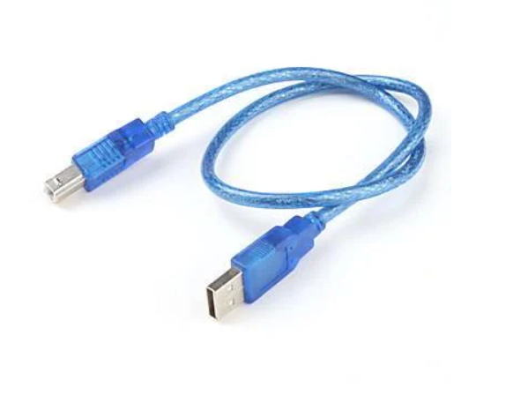

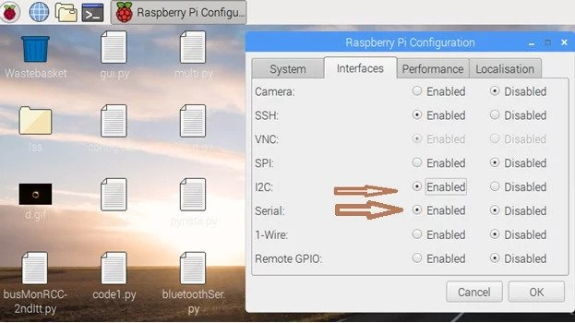For communication, we will use simple serial communication over USB cableand be sure to enable Serial and I2C in PiConfig.

**Send data from temperature sensor which is connected to Arduino and send data to Raspberry-Pi database.**

The Arduino Uno board has one UART that you can use either with a USB cable or from the RX/TX pins.

On the Raspberry Pi, you can connect many Serial devices on the USB ports. We can also use the GPIOs (RX0/TX0) for an additional UART.

Hardware setup for Serial communication

Serial via USB

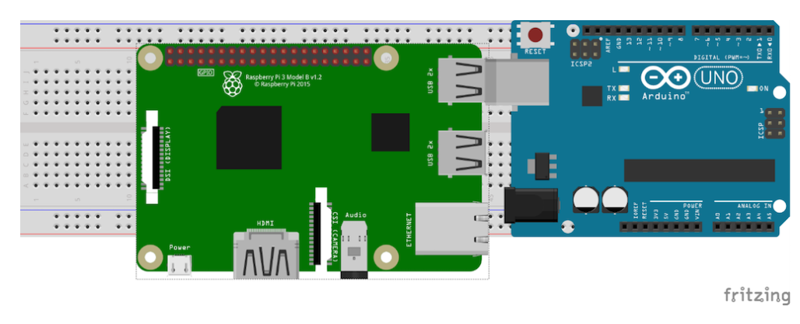

We will first need to connect your Arduino to your computer, so we can upload the code into the board. After that, connect the USB cable to the Raspberry Pi. The Raspberry Pi will power the Arduino via this cable.

Interfacing DHT11 temperature sensor with Arduino uno

**Arduino code**

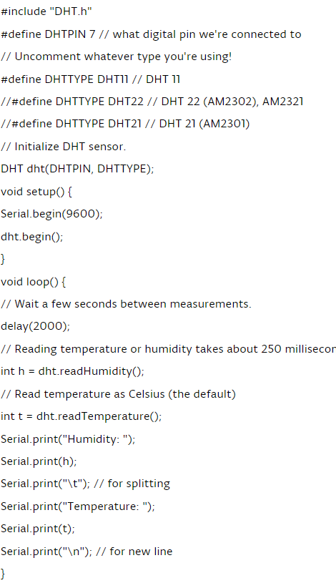

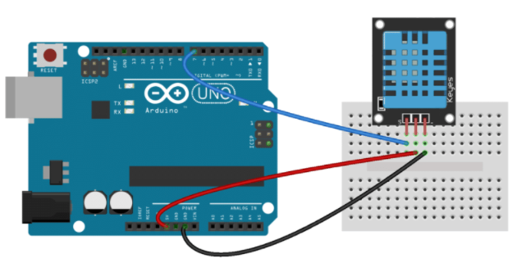

### Raspberry Pi Python code



